**Mortality Data Description**

The data you have been given is from a famous study titled the SUPPORT study, in which researchers tried to develop models for short-term mortality predictions of terminally ill patients and to help develop tools to aid clinicians in communicating information to these patients about their prognoses. You will use this data to build a model to predict 6-month mortality. The data set, “MortData_student.csv”, has multiple attributes (as shown below) and an output variable, “death.”

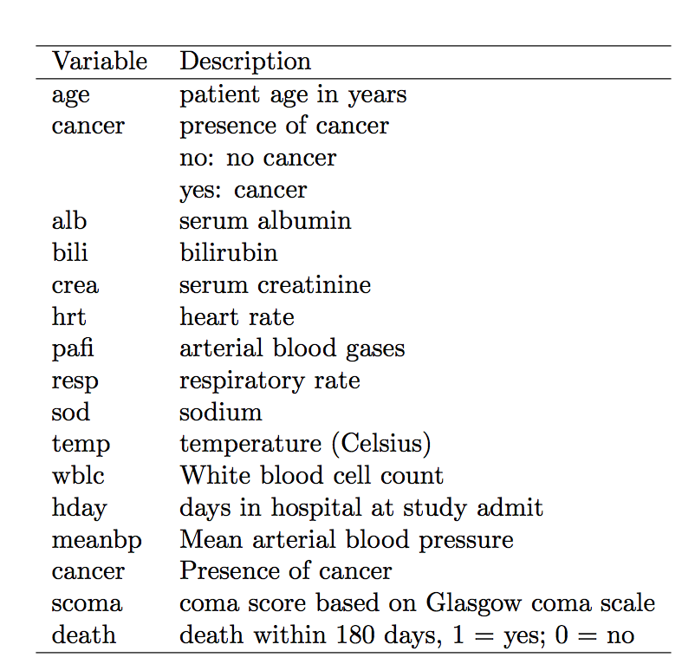

alb: liver, low is bad

bili: liver, high is bad

crea: kidney, high is bad

hrt: heart beat, high is bad

pafi: blood gases (might be missing bc of ventilation, several times sicker)

resp: respiratory rate, ventilation rate

sod: sodium

temp: might get Fahrenheit results

wblc: White blood cell count

hday: days in hospital before admitted in the study (data taken 3 days into study)

meanbp: mean blood measure

scoma: coma score

death: death within 180 days, 1 = yes, 0 = no

shock index: heart rate/sbp

(SI)

adj. SI = HR / MBP

ARF: Acute Respiratory failure (usually multiple organ failure starts from lungs)

COPD: Heart Failure